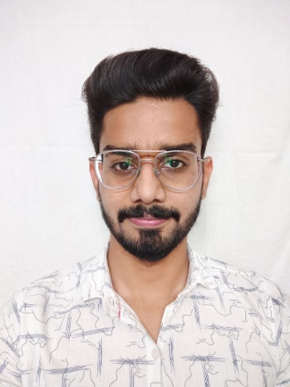
MR. VIVEK KUMAR
Email: vivekbharadwaj16@gmail.com
EDUCATION: B. Pharm (G.L.A. University, Mathura, 2021)
CURRENT COURSE: M. Pharm-Pharmaceutical Chemistry (Jamia Hamdard, 2023)
RESEARCH TITLE: Design, Synthesis and in-vitro evaluation of Pyridine-Pyrimidine hybrids as novel Anti-Alzheimer’s agents
REGISTRATION NO: 2021-518-009 REGISTRATION DATE: 17-08-2021
SUPERVISOR: Prof. (Dr.) Mohammad Mumtaz Alam CO-SUPERVISOR-1: Dr. Mohammad Shaquiquzzaman
FELLOWSHIP: GPAT Fellowship
PUBLICATIONS:
- Tathagata Pradhan, Ojaswi Gupta, Vivek Kumar and Gita Chawla (2022): A comprehensive review on the antidiabetic attributes of thiazolidine‐4‐ones: Synthetic strategies and structure-activity relationships. Archiv der Pharmazie, e2200452. DOI: 10.1002/ardp.202200452.
- Somdutt Mujwar and Vivek Kumar (2020). Computational Drug Repurposing Approach to Identify Potential Fatty Acid-Binding Protein-4 Inhibitors to Develop Novel Antiobesity Therapy. Assay and drug development technologies, 18(7), 318-327. DOI: 10.1089/adt.2020.976
CERTIFICATIONS AND ACHIEVEMENTS:
- Three weeks course on Drug Development by University of California San Diego (8ZAYGWQ4S67N).
- Ten weeks course on Introduction to Systems Biology by Icahn School of Medicine at Mount Sinai (E9QDQP44YCWV).
- four weeks course on R Programming by Johns Hopkins University (9DP6LUDLV9PH).
- University Gold Medal from G.L.A. University Mathura for securing University Rank 01 in B. Pharm (2017-2021).
- Academic excellence scholarship for pursuing B. Pharm by GLA University for 4 years.
SYMPOSIUM AND POSTER PRESENTATIONS:
- Presented poster on “Pharmacoepidemiology”, “Current Trends in Future Medicine” and on “Radiopharmaceuticals” in AMU, 2018.
- Presented poster at Innovation Conclave organized by CTSI, Jamia Hamdard on topic “Drugs Repositioning techniques to identify potential DDR1 inhibitors as new anti-breast cancer agents”.
PROFESSIONAL CREDENTIALS:
ORCID ID: 0009-0004-9543-5935 LinkedIn: https://www.linkedin.com/in/vivek-sharma-020220119/
PROFESSIONAL MEMBERSHIP OF SOCIETIES:

