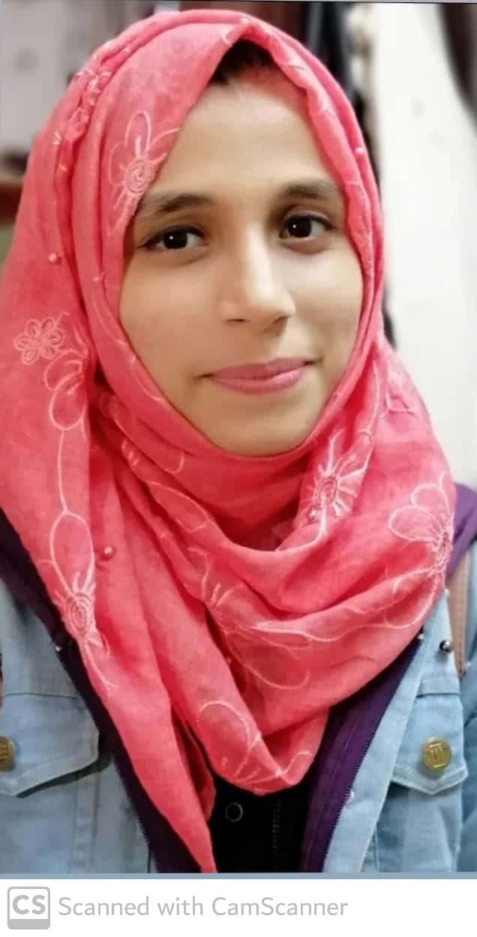
MS. MARIYA JAHANGIR Email: mariyaja16@gmail.com
EDUCATION: M. Pharm (Jamia Hamdard 2023); B. Pharm (Jamia Hamdard)
RESEARCH TITLE: DESIGN AND SYNTHESIS OF NOVEL AGENT FOR THE TREATMENT OF ALZHEIMER’S DISEASE
REGISTRATION NUMBER: 2021-518-004 REGISTRATION DATE: 10-08-2021
SUPERVISOR: Prof. (Dr.) Mymoona Akhter
FELLOWSHIP: NA
PUBLICATIONS: NA
TEACHING EXPERIENCE: NA

SYMPOSIUM AND POSTER PRESENTATIONS:
- Secured Second place in Oral presentation on “Network Biology Approach for Design And Synthesis Of Novel Agent To Improve Cognition In Dementia And Alzheimer’s Disease “at School Of Pharmacy, Sam Global University, Bhopal Organized By APP Madhya Pradesh Branch & APP Brazilian International Branch
- Presented poster in Innovation Conclave-22 on “The Exigency for Early Detection and Intervention In Alzheimer’s Disease” organized by Jamia Hamdard University during November 17.
PROFESSIONAL CREDENTIALS:
Scopus ID: NA ORCID ID: 0009-0009-2087-2600 LinkedIn: https://www.linkedin.com/in/mariya-jahangir-a935ba23b
PROFESSIONAL MEMBERSHIP OF SOCIETIES:
Life Member, Association of Pharmacy Professionals (APP)

